COURIER SERVICE SYSTEM
ABSTRACT
A courier service system which is mainly used to tracking the courier. Which is the software by using 2 users. One is a courier office employee another one is a customer, here customer is an who has to be sending the courier.
An employee can be login by using username and password then managing the entire life cycle. After the login the employee can register the courier information along with from and to places. Here the employees can check the daily billing details history via this application.
When the courier reaches at the hub the courier team employees should entry with courier detail. Each courier having some unique ID by using this unique ID the customer can track the courier up to date details.
The main goal of this project is that reducing the man power and giving an accurate information to the customer, the customer can track the accurate courier location. The project is aimed to develop by JAVA as Front end and SQL as Back end.

SYSTEM SPECIFICATION
HARDWARE SPECFICATION:
- Processor : P 4 700 GHz.
- RAM : 4 GB RAM
- Hard Disk Drive : 180 GB

SOFTWARE SPECIFICATION:

  - Operating System : Windows 7/8/10
  - Front End : JAVA
  - Back End : SQL
EXISTING SYSTEM:
In this system customer can’t track their courier details. If we want know about the courier details, we should visit the store and ask about the details. Otherwise, we can’t track the details. Sometimes customer has felt about the courier, in this kind of existing system has more trouble to run

DRAWBACKS:
The existing system has the following drawbacks.
- we don’t know about the courier details.
- We don’t know about the current status of the courier
- It’s fully managed by the courier office team

PROPOSED SYSTEM:
This courier tracking system may help to track the courier by the customer. It can be very useful to tracking our courier detail. We don’t bother about the courier. The customer has one unique id with the help of that id we can track our courier details, each and every courier has updated
FEATURES:
- We know about the courier details.
- No need visits the courier office.
- Fully manually find the courier details

MODULES
Register Customer
Administrator will register their customer. They can see all the details about the customer. After creating an account, they will track their courier manually. In this module collect all the information about the customer, it has to be used for further contact to a customer.
Booking order
This module is used to booking the order, after the order was booked the it will be tracking. Before booking the order, admin should collect all the information about the courier, then it will be tracking.
Track Order
Once the order was confirmed then customer have an one unique id, this will helps to track an order and order details. Customer manually track the courier after the courier will be updated once.
Billing Details
This module will manage the billing details, administer will see the daily billing details.
In this module has to completely showing all the information about the courier and customer. And also, will see the daily billing details.
Report Module:
In this module will be showing an overall report to the courier, customer enter the courier number then it will be showing the last update of the courier. This is an main concept of the courier tracking.
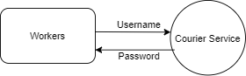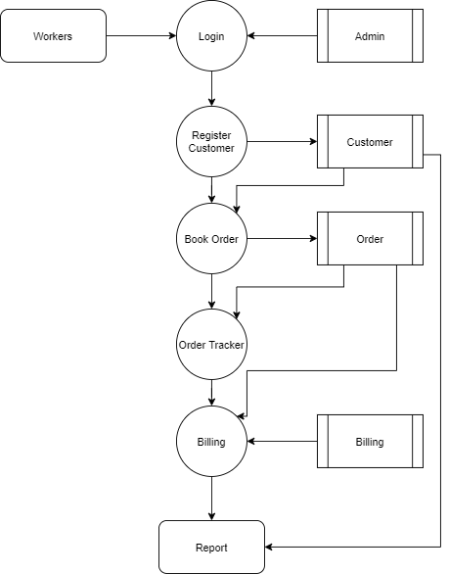

TABLE NAME: ADMIN

FIELD | DATA TYPE | SIZE | CONSTRAINT
Admin id | Int | 10 | Primary key
Username | Varchar | 20 | Not null
Password | Varchar | 20 | Not null

TABLE NAME: CUSTOMER

FIELD | DATA TYPE | SIZE | CONSTRAINT
Customer id | Int | 10 | Primary key
First name | Varchar | 20 | Not null
Last name | Varchar | 20 | Not null
Address | Varchar | 30 | Not null
Mobile | Int | 10 | Not null
Email | Varchar | 20 | Not null
Age | Int | 2 | Not null
Gender | Varchar | 7 | Not null
City | Varchar | 15 | Not null

TABLE NAME: ORDER

FIELD | DATA TYPE | SIZE | CONSTRAINT
order id | Int | 10 | Primary key
Mobile | Int | 10 | Not null
Name | Varchar | 30 | Not null
Send location | Varchar | 20 | Not null
From location | Varchar | 20 | Not null
Full Address | Varchar | 50 | Not null
Weight | Int | 5 | Not null
Discount | Int | 5 | Not null
Amount | Int | 6 | Not null

TABLE NAME: BILL
PRIMARY KEY: bill id

FIELD | DATA TYPE | SIZE | CONSTRAINT
Bill id | Int | 10 | Primary key
Customer id | Int | 10 | Foreign key
Amount | Int | 10 | Not null
Bill date | Date | 10 | Not null

